ETHICAL SOFTWARE Community

NVIDIA Driver on Fedora Linux 36

Table of contents

NVIDIA Driver on Fedora Linux 36 1
Install NVIDIA Driver on Fedora Linux 36 1
Now Install NVIDIA Drivers on Fedora 8

Install NVIDIA Driver on Fedora Linux 36

For NVIDIA Graphic Card to work on Fedora Linux 36, we have to install the NVIDIA Driver! Let’s start!

P.S. If you have any concerns regarding this tutorial, please refer to this link.

Step 1. First, on your Fedora, move your mouse to the top-left corner of your screen.
You should see the following screen:

Example Output:
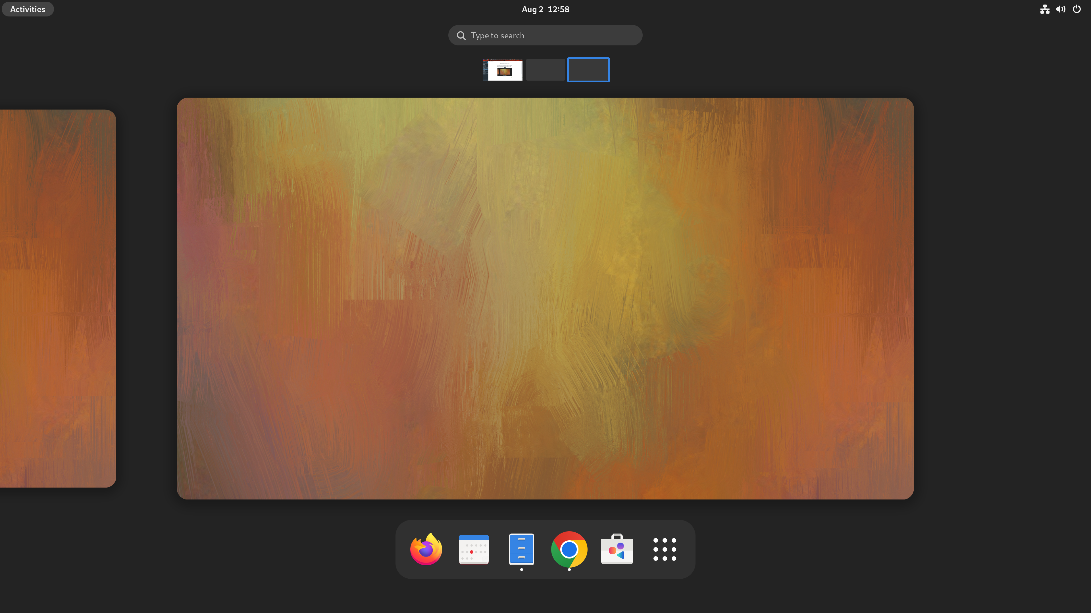

Step 2. Left Click “Type to search”.
Example Output:
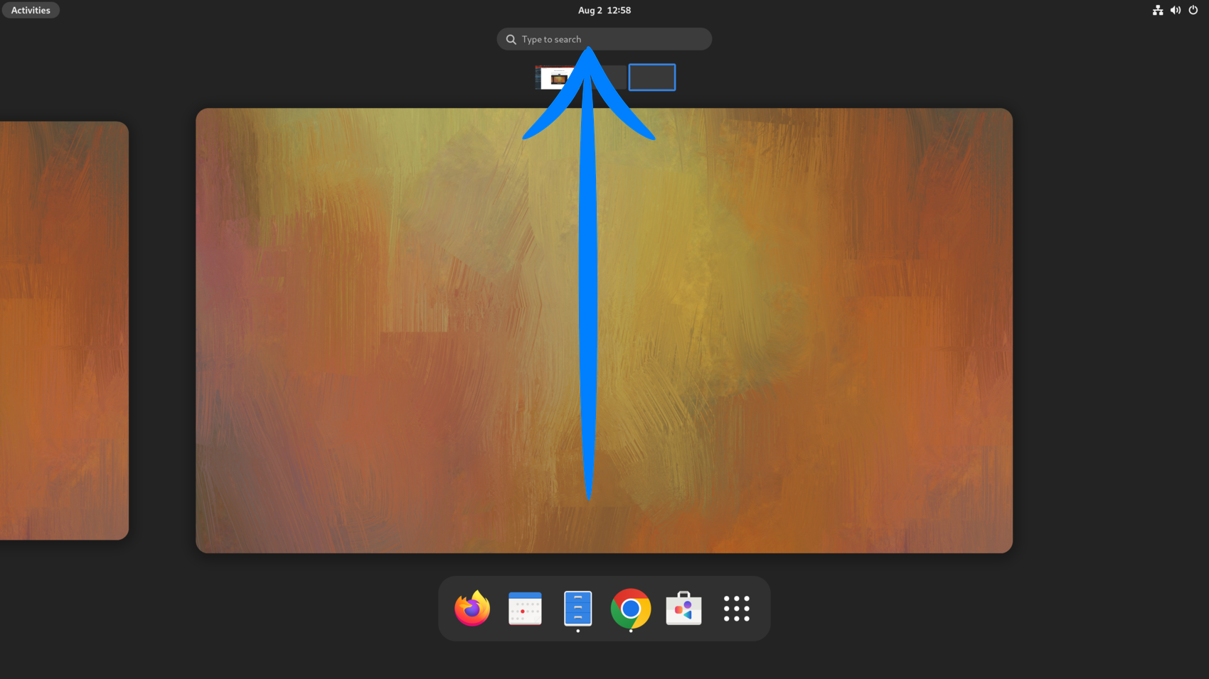
Step 3. Enter the word “Terminal”.

Example Output:
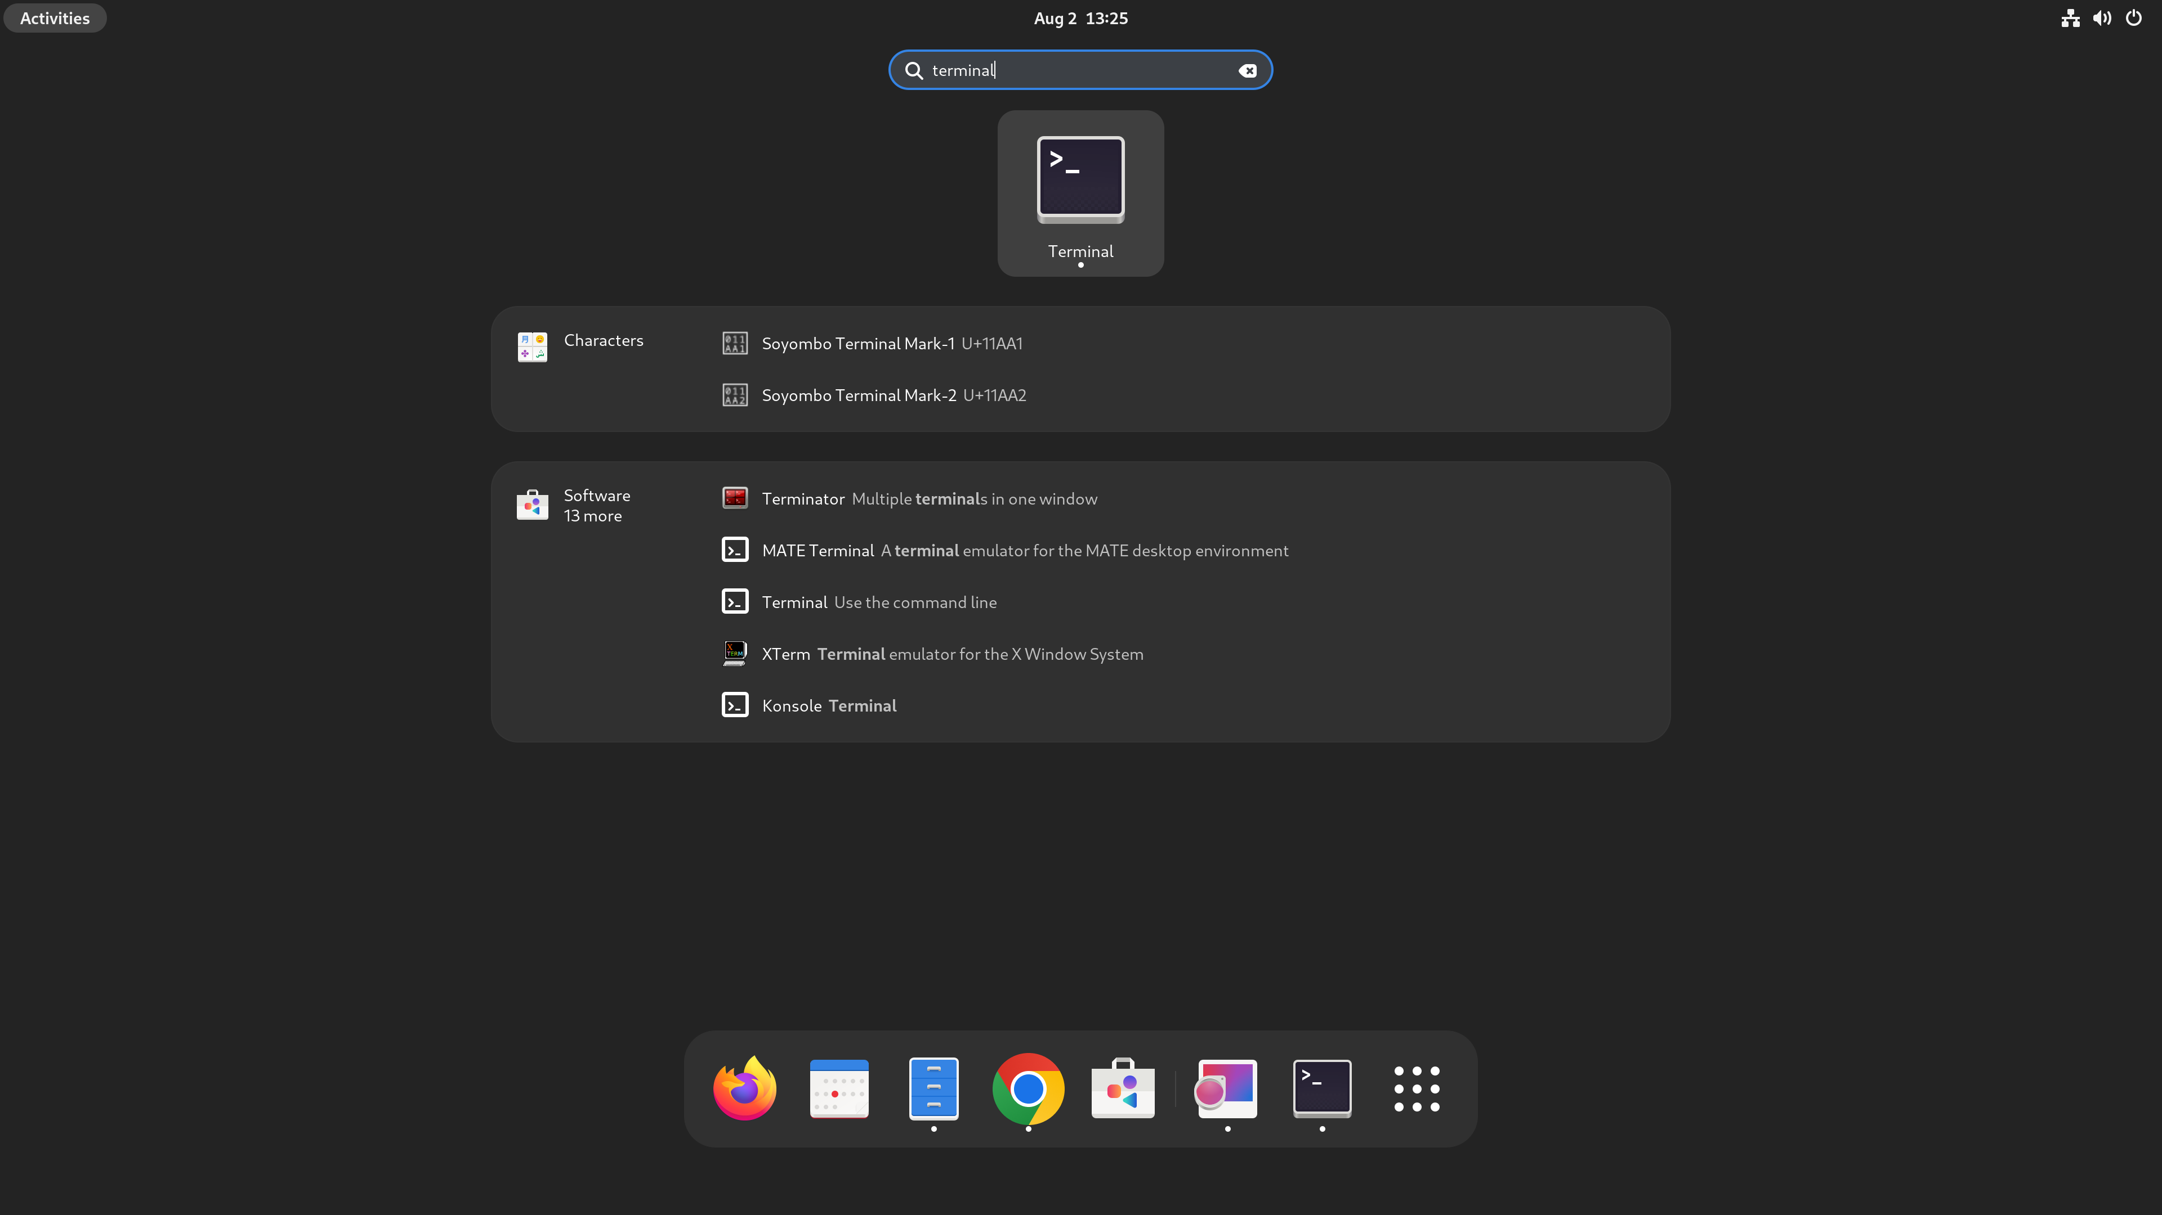
Step 4. After Left Clicking on the Terminal Icon. You should see the following terminal pop out.
Example Output:
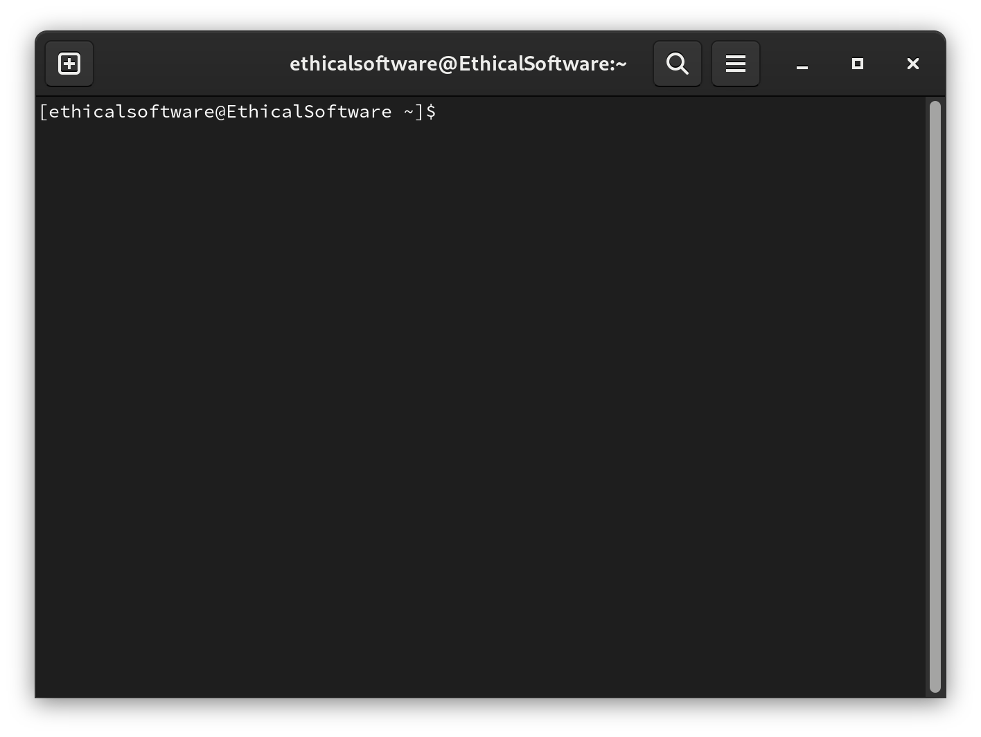
Step 5. Enter the below command in the terminal forUpdating Fedora and enter your user password:
It might take around 10 minutes if it is the first update.
sudo dnf upgrade --refresh -y

Example Output:
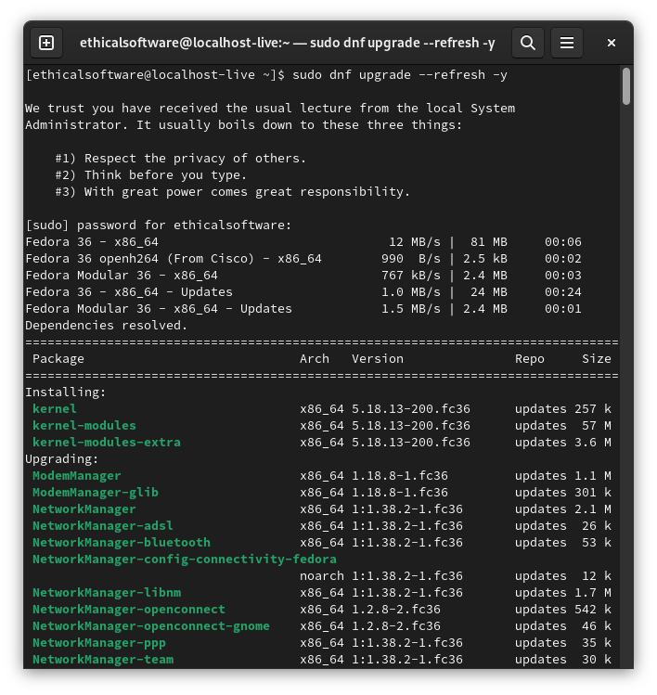
Step 6. Enter the below command in the terminal for Enabling RPM Fusion Free and enter your user password. Enter the “y” key to confirm installing Rpm Fusion.
sudo dnf install https://download1.rpmfusion.org/free/fedora/rpmfusion-free-release-$(rpm -E %fedora).noarch.rpm

Example Output:
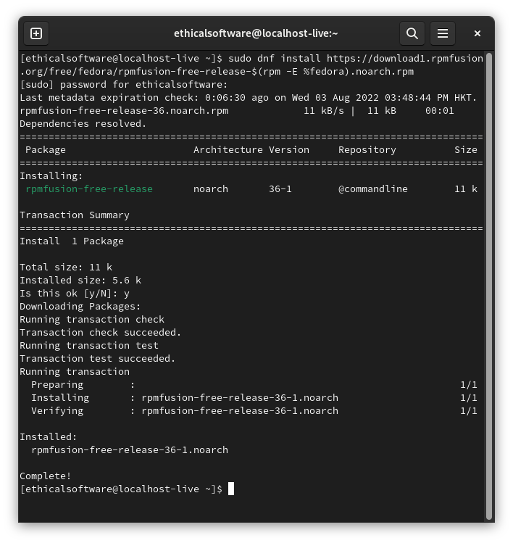

Step 7. Enter the below command in the terminal for Enabling RPM Fusion Non-Free. Enter the “y” key to confirm installing Rpm Fusion.
sudo dnf install https://download1.rpmfusion.org/nonfree/fedora/rpmfusion-nonfree-release-$(rpm -E %fedora).noarch.rpm

Example Output:
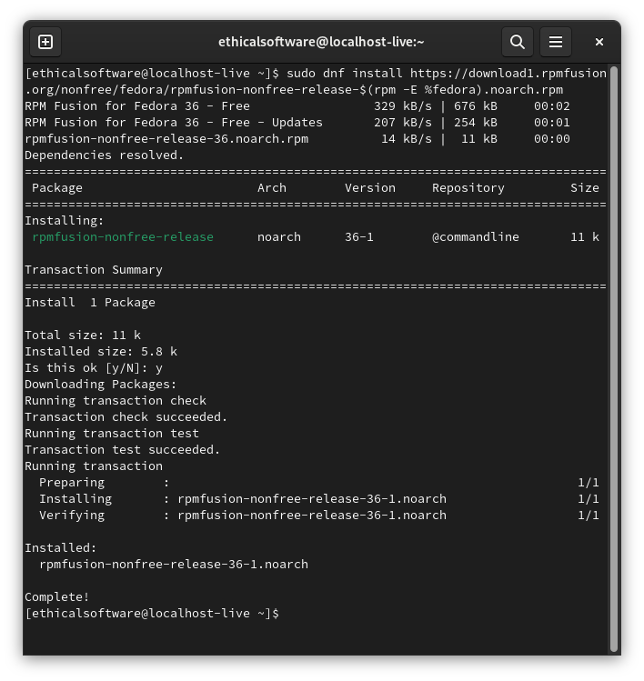
Step 8. Enter the below command in the terminal to refresh your repository list.
sudo dnf update –refresh
Example Output:
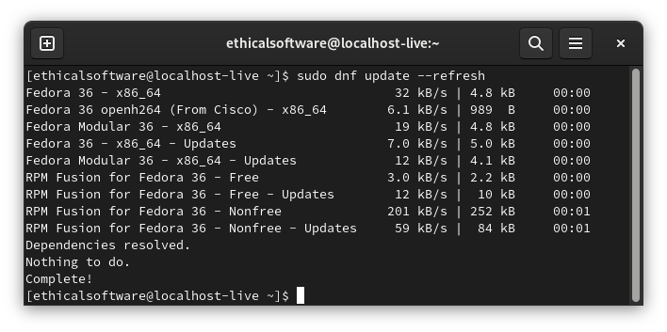

Now Install NVIDIA Drivers on Fedora

Step 9. Enter the below command in the terminal to install the latest NVIDIA drivers on your Fedora system.
It might take several minutes.
sudo dnf install akmod-nvidia -y

Example Output:
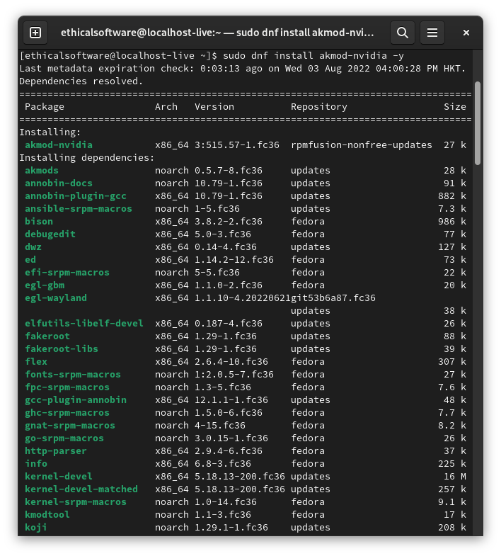
Step 10. Enter the below command in the terminal to install the CUDA Driver support as it can help solve problems if issues persist with the driver.
Enter your password if you are asked to.
Enter the “y” key to confirm installing Rpm Fusion.
sudo dnf install xorg-x11-drv-nvidia-cuda

Example Output:
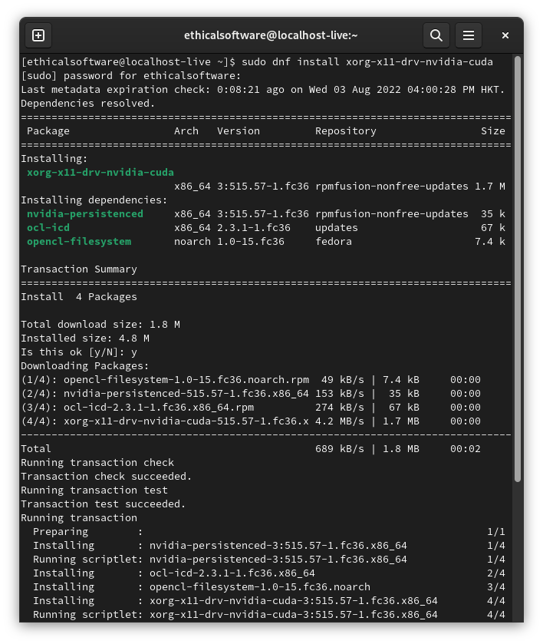
Step 11. Enter the below command in the terminal to reboot your PC
reboot
Step 12. After the PC reboot, repeat Steps 1- 4 to open a new Terminal. Enter the below command in the terminal to verify whether or not the NVIDIA Drivers are installed.
nvidia-settings

Example Output if no Error:
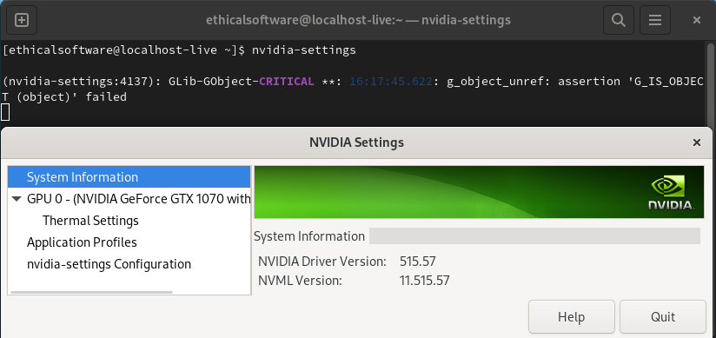Please contact the Linux Support Officer for further assistance if you encounter any issues or concerns.

E.N.D

https://www.linuxcapable.com/how-to-install-nvidia-drivers-on-fedora-36-linux/

